Date: 04.04.2025
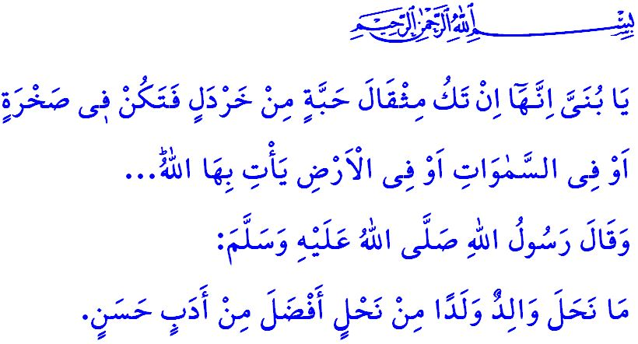THE ROLE OF PARENTS IN BUILDING A STRONG SOCIETY
Honorable Muslims!
One day, a man came into the presence of the Prophet Muhammad (saw) and said, “O Messenger of Allah! I owe allegiance to you for migration and Jihad seeking reward only from Allah.” Thereupon, the Messenger of Allah (saw) asked, “Are your mother and father still alive?” When the man replied, “Yes, both of them are alive,” the beloved Prophet (saw) advised him, saying, “Go back to your parents and accord them benevolent treatment.”
Dear Believers!
One of the most precious blessings bestowed upon us by Allah the Almighty is our parents. Our mother is the first teacher who sows the seeds of compassion and love in our hearts; she is the one who instills in us the awareness to distinguish good from evil, right from wrong, truth from falsehood. Our mother is a symbol of mercy and compassion, who upholds the family, offers unconditional love to her children, and raises generations that benefit humanity. Our father, on the other hand, is like a mighty plane tree upon whose trunk we lean in the face of life’s hardships and difficulties. He is a strong fortress where we can seek refuge against all forms of evil and threats. In short, our parents are distinguished individuals who patiently prepare us for the future and whose places can never be filled. Respecting them is respecting Allah. Honoring them is honoring Allah. Their prayers are the key to Paradise. Their legitimate requests and advice, in accordance with Islam, are the source of peace and tranquility.
Esteemed Muslims!
A responsible mother should be like Hajar, who endured all hardships for the sake of the Prophet Isma‘il, striving tirelessly to fulfill both his material and spiritual needs. She should be like Fatimah, the cherished blossom of the Ahl al-Bayt of Mustafa, who raised our masters, Hasan and Husayn.
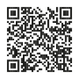
A responsible father should strive, like the Prophet Nuh, who said, “O my dear son! Come aboard with us...” in his effort to save his child from evil. He should be like Luqman, who instilled in his child the awareness of accountability with the advice, “O my dear son! ˹Even˺ if a deed were the weight of a mustard seed—be it ˹hidden˺ in a rock or in the heavens or the earth—Allah will bring it forth…” who called his child to prayer, goodness, truth, and righteousness with the counsel, “O my dear son! Establish prayer, encourage what is good and forbid what is evil, and endure patiently whatever befalls you…” and who taught his child courtesy and good manners with the advice, “And do not turn your nose up to people, nor walk pridefully upon the earth… Be moderate in your pace. And lower your voice…”
Dear Parents!
The Prophet Muhammad (saw) stated in a hadith, وَإِنَّ لِوَلَدِكَ عَلَيْكَ حَقًّا “Indeed, your child has a right over you.” According to our religion, we are responsible for providing our children with halal sustenance, giving them beautiful names that are pleasing to Allah, and treating them with compassion. We are obligated to raise them as righteous individuals who love their homeland, state, and nation, and who are committed to their national and spiritual values. It is their right upon us to teach them the Qur’an and the exemplary life of the Prophet Muhammad (saw), to equip them with authentic religious knowledge, and to adorn them with the morals of Islam.
Dear Believers!
Today, our children are faced with grave dangers that threaten both their worldly life and their Hereafter. They are being lured into the swamp of alcohol, gambling, and drugs, and into the traps of immorality. Harmful movements and false ideologies are striving to enslave our youth. Therefore, we must make even greater efforts to ensure that our children become servants of Allah the Almighty who earn His pleasure, and grow into individuals who are beneficial to society and humanity. We must strive even more so that our children become a generation that upholds social peace and harmony, adhering to the command of Allah the Almighty: وَتَعَاوَنُوا عَلَى الْبِرِّ وَالتَّقْوٰىۖ وَلَا تَعَاوَنُوا عَلَى الْاِثْمِ وَالْعُدْوَانِۖ “…Cooperate with one another in goodness and righteousness, and do not cooperate in sin and transgression…” We must be role models for our children through our character, our words, and our actions, and we must never deprive them of our attention and love. Let us not forget that the path to building a strong society lies in being parents who bear the responsibility of raising a generation that is devoted to its faith, committed to its acts of worship, connected to its history and culture, respectful of sacred values, observant of prayers, obedient to the commands of Allah, and distant from His prohibitions.
I conclude this Friday’s khutbah with the following hadith of the Prophet Muhammad (saw): “There is no gift that a father gives his child more virtuous than good manners.”

Muslim, Birr, 1.
Hud, 11/42.
Luqman, 31/16.
Luqman, 31/17.
Luqman, 31/18-19.
Muslim, Siyam, 183.
Ma’idah, 5/2.
Tirmidhi, Birr, 33. General Directorate of Religious Services

